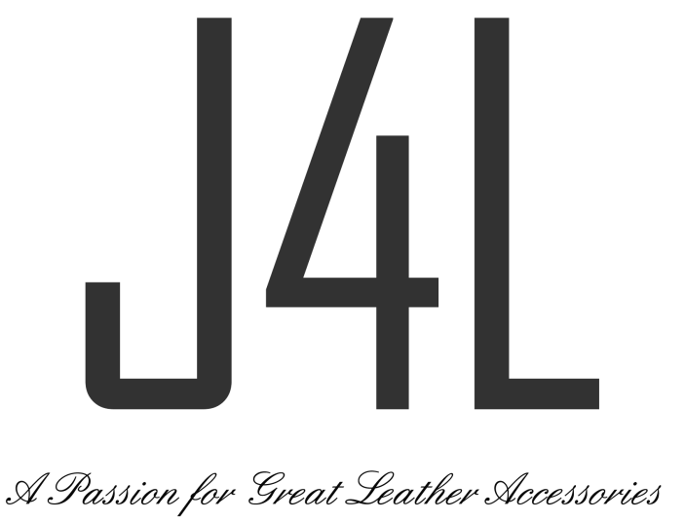

Product Returns Form

Need to return something? Simply fill in the form and send it back to us with the items.
Simply fill in the form and send it back to us with the items within 14 days of receiving your delivery -

1 – Your Details

Name:  Address: | Order No:  (Found on your order confirmation email/delivery note)

2 - Next to the products listed below, please select one of the reason codes best describing your return.
Items can only be returned for refund. You can place a new order if a replacement size, colour or alternative items are required, and return the original items to us for a refund.

Qty: | Product code:  (ie 16-600-BLK) | Reason Code: | Reason For Reason Code  1 - LOOKS DIFFERENT TO IMAGE ON SITE  2 - ORDERED 2 ITEMS TO COMPARE  3 - ARRIVED TOO LATE  4 – FAULTY UPON DELIVERY  5 - DOESN'T FIT MY LAPTOP/DEVICE  6 - DOESN'T SUIT ME  7 - INCORRECT ITEM RECEIVED  8 – OTHER (Please provide reason)

All new items returned for a refund must be in original packaging and will be inspected prior to any credit being issued. We can only issue refunds for items purchased directly from the just4leather.co.uk website. For items purchased from other retailers you will need to contact the retailer directly for a refund. Refunds will cover cost of your original purchase, excluding delivery charges.

If you have any queries or need help – please email customer-support@just4leather.co.uk or call 0843 886 0898.

